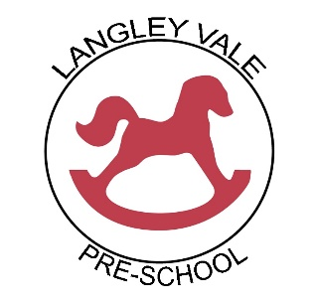

**Smoking, Alcohol and Drugs**

Last reviewed: January 2023 to be reviewed by: January 2024

Responsible member of staff: ……………………………………….. Date: ……………………………….

Responsible member of committee: …………………………….. Date: ……………………………….

|  |  |  |  |
| --- | --- | --- | --- |
| A unique child | Positive  Relationships | Enabling  Environment | Learning and development |
| Inclusive practice | Respecting each other | Learning environment  Wider context | Personal, Social & Emotional Development |

Our Pre-school prohibits the use of cigarettes, Vaping, alcohol and illegal drugs on our premises at any time. If staff, students, volunteers or children are found to have broken the rules in respect of this policy, it will be treated as a disciplinary matter.

All staff will be made aware of the provisions of this policy during their induction, including the importance of them setting a positive example to children. All children will be made aware of the rules during their settling in period. Any contravention of the provisions of this policy will be dealt with under the Pre-school’s staff disciplinary procedures within the provisions of the Staffing and Behaviour Management Policies.

**Drugs**

Staff, students or volunteers who arrive at the Pre-school and are suspected to be under the influence of drugs and considered unfit to work, will be asked to leave immediately and disciplinary procedures implemented.

If staff are found in possession of illegal drugs, serious disciplinary action will follow.

In cases where staff are taking prescribed drugs that may affect their ability to function effectively at work, the Supervisor must be informed as early as possible.

If a member of staff has good reason to suspect that a parent/carer is under the influence of illegal drugs when they drop off or collect their child, they have a duty to inform both the Supervisor and the Pre-schools designated Child Protection Officer, according to the provisions of the Safeguarding Children policy.

In such circumstances, the Supervisor and the Pre-schools Child Protection Officer will then be responsible for deciding upon the appropriate course of action, ensuring that the safety and protection of the child remains paramount at all times.

Staff will make all possible efforts to ensure that children are not allowed to travel in a vehicle driven by someone who is clearly under the influence of illegal drugs.

Where an illegal act is suspected to have taken place, the police will be called.

**Alcohol**

Staff, students or volunteers who arrive at the Pre-school clearly under the influence of alcohol, will be asked to leave immediately and disciplinary procedures will follow.

If a member of staff has good reason to suspect that a parent/carer is under the influence of alcohol when they drop off or collect their child, to the extent that the safety of the child is threatened, they have a duty to inform both the Manager and the Pre-School’s Designated safeguarding Lead (DSL), according to the provisions of the Safeguarding Children policy.

The Manager and the DSL will then be responsible for deciding upon the appropriate course of action, ensuring that the safety and protection of the child remains paramount at all times.

Staff will make all possible efforts to ensure that children are not allowed to travel in a vehicle driven by someone who is clearly under the influence of alcohol.

Where an illegal act is suspected to have taken place, the police will be called.

Ofsted may be informed.

**Smoking**

Smoking and vaping is not permitted anywhere on the premises. This rule applies equally to staff, students, volunteers, children, parents/carers or any other visitors.