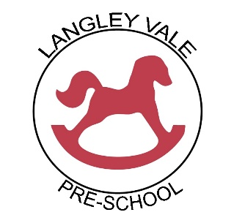

**Student Placement Policy**

Last reviewed: January 2023 to be reviewed by: January 2024

Responsible member of staff: ……………………………………….. Date: ……………………………….

Responsible member of committee: …………………………….. Date: ……………………………….

|  |  |  |  |
| --- | --- | --- | --- |
| A unique child | Positive  Relationships | Enabling  Environment | Learning and development |
| Inclusive practice | Respecting each other | Learning environment  Wider context | Personal, Social & Emotional Development |

This policy represents the agreed principles for Student placement throughout the Pre-School. All Pre-School staff, representing Langley Vale Pre-School have agreed this policy.

We recognise that the quality and variety of work, which goes on in a Pre-School, makes it an ideal place for student on placement from school and college child care courses as well as those on the diploma in Pre-School practice.

Students are welcomed into the Pre-School on the following conditions:

The needs of the children are paramount.

Students will not be admitted in numbers which hinder the essential work of the Pre-Schooll.

Students required to carry out child studies will obtain written permission from the parents of the child to be studied.

Students must be confirmed by their tutor as being engaged in a bona fide childcare course, which provides necessary background understanding of children’s development and activities.

Any more information gained by the students about the children, families or other adults in Langley Vale Pre-School must remain confidential. Records of information will be held at the Pre-School.

Students will never be left unattended with children.

Students must have a DBS check before starting at Pre-School.

Unless registered as a fit person, a student will not have unrestricted access to children. If for any reason the staff, children or parents are unhappy with a student then it will be necessary for he or she to leave immediately.

Staff/ volunteers/ students under the age of 17 cannot count towards the ratio and should be supervised at all times.

Individuals aged 17 and over who are on a long-term placement may be included in the ratios if the provider is satisfied, they are competent and responsible.

Mobile phones are not allowed on site.

Managers must be provided with all personal details (including medical needs) and emergency contact details for all students.

Langley Vale Pre-School always welcomes visits from tutors to discuss students on placement.